# Explorations of alternative Pacific cod models for 2024

Author: Steven J. Barbeaux

# Introduction

For 2023 the authors wished to examine outstanding problems common to all four of the eastern Bering Sea (EBS) Pacific cod ensemble models accepted for management in 2022. The two main issues with the ensemble models were: 1) for the length composition data the Dirichlet multinomial log(theta) values approach the upper bound and therefore needed to be fixed for the model to converge, 2) failing residual runs tests for length and age composition data in all ensembles indicating autocorrelation in the residuals indicating poor residual behavior, and 3) confounding of aging bias, annually varying growth, and annually varying selectivity result in the models being highly sensitive. For example a profile over catchability demonstrates that changes in catchability results in substantial changes in management advice with only small changes in negative log likelihood (Fig. 1). Here we see a ~150k ton range in 2023 ABC with a less than 10 -LL change from the MLE (total –LL 10875.3).

For 2023 we conducted a series of model explorations in an attempt to fix these issues. From these investigations, a prominent insight emerged: the models for Pacific cod displayed notable variation in survey catchability spanning a range from 0.74 to 1.10 and was highly negatively correlated (R2 = -0.93) with natural mortality ranging from 0.33 to 0.44. This variability could imply a strong responsiveness of cod growth and recruitment to environmental factors. The fluctuations in growth and recruitment significantly contribute to the overall biomass's variability, leading to limited insights into the consequences of fishery removals. It's crucial to emphasize that catchability is influenced by the degree to which catch impacts changes in survey abundance. Given the considerable impact of environmental drivers on cod abundance and mortality, there's a possibility of insufficient data for accurately determining survey catchability.

## Changes in input sample size

The first examination we conducted for 2023 was to change the input sample size for fishery size and survey size and age composition data from being based on survey sampled haul number to a bootstrap approach (Hulson et al. 2023). In their publication Hulson et al. (2023) noted that there was not a consistent approach to setting input sample sizes for composition data fit in assessment models at the Alaska Fisheries Science Center (AFSC). For the 2022 Pacific cod ensemble models the input sample sizes for the survey size and age composition data were set at the number of surveyed hauls for each year, and the fishery size composition data were set at the number of hauls sampled standardized to the mean sample of hauls from the survey over all years surveyed. This led to an average input sample size of 369 for both survey and fishery length and age compositions (Table 1). As noted the ensemble models were fit using the Dirichlet multinomial which as coded in Stock Synthesis uses a parameter (log theta) to reweight the data and in effect reduce the size and age composition input sample sizes. In all of the 2022 ensemble models the DM log theta parameter fits to the upper bound for both the fishery and survey size composition data and must be fixed in order for the model to converge. Having the DM theta parameter fixed at the upper bound is not optimal and may indicate that input sample sizes for the size composition data are too small. Using a bootstrap approach (Hulson et al. 2023) for calculating input sample size for the survey length and age composition data results in an on average smaller age composition sample size of 250 (in agreement with the fitted DM theta value of -0.47) and a much larger on average input sample size of for the size composition data of 1661 (Table 1). For the fishery size composition data input sample size we used the annual number of hauls sampled standardized to the mean survey size composition input sample size so that both means were equal. Model 22.2 was then fit using these new sample sizes. The overall negative log likelihood (-LL) increased from 10,875 to 18,362, with a sharp increase in the length composition -LL from 9,990 to 17,383 shifting more weight to the composition data. The DM log theta values for the survey age composition data went from -0.47 to -0.60 and the survey size composition went from near the bound at 10 in the old model to 1.32 in the updated model. However the fishery size composition DM log theta remained at the bound suggesting the sample sizes remained too low in comparison with the other data components. The change resulted in substantially more weight on the composition data than in the old Model 22.2 and a degradation in fit to the survey (Table 2 and Table 3) from -6 -LL to 68 –LL. Retrospective and mean absolute scaled error (MASE) values were the same between the two model configurations (Table 4) and the fishery size composition residuals remained significantly correlated. However the change resulted in better residual behavior for the survey size and age composition (Table 5). Convergence was impacted with an increase in local minima and a large number of jitter runs failing to converge at the MLE for the updated model. The profile over catchability for the updated Model 22.2 (Figure 1) shows an irregular profile resulting from the models not converging to the MLE for each of the fixed catchability values. For both the old and updated Model 22.2 catchability and natural mortality are highly correlated (Figure 2) with a slightly higher M in the model with updated input sample size. The updated Model 22.2 growth parameters were different from the old Model 22.2 driven entirely by the different input sample sizes (Table 6) and changes in relative weighting of the data components, however these changes in growth parameter had little impact on the overall size at age (Figure 3). Additional changes in influential parameters are shown in Table 7. Despite changes in important parameters such as catchability and natural mortality both model configurations resulted in similar reference points and management advice (Table 8).

In an attempt to find out whether changing from the DM to standard multinomial and implementing the Francis TA1.8 weighting method for Model 22.2 could improve model performance we found that when iteratively fitting the model the suggested correction to the fishery size composition value continued to increase without settling until the model no longer converged. This was taken to indicate some level of model misspecification generating a need to evaluate new model configurations to track down the issues.

## Simplified Model 23.1.0.A Description

To allow an easier understanding of the interaction of model components on model results and model sensitivities we created a simplified version of Model 22.2 (Barbeaux et al. 2022). The new simplified Model 23.1.0.A has the following changes from the updated Model 22.2:

1. Removing length composition data for years with age composition data (1994-2021) which were duplicated in the age comps
2. Reconfiguring both survey and fishery selectivity to be static instead of including annually varying parameters
3. Reconfiguring the Richard’s growth to be static instead of including annually varying Lmin
4. Reconfiguring survey selectivity to estimate parameters 1-4 and using new asymptotic option for parameter 6
5. Fixing pre-2007 bias to Model 22.2 values instead of fitting them in the model
6. For the growth model fixing CV at older ages at 0.06 and fixing CV at younger ages at 0.2
7. Changing from the Dirichlet multinomial to standard multinomial for length and age composition data
8. Using the iterative Francis TA1.8 weighting method to balance weighting within the model

### Duplicate composition data

For the 2022 ensemble models both survey and age composition are included for all years in which they are available, resulting in 1994-2021 having both survey age and survey size composition data included in the model. Therefore the survey composition data for these years are potentially more highly weighted in the models than other data components. In the exploratory models for the years with bottom trawl survey age composition data (1994-2019, and 2021), the bottom trawl survey size composition data were removed.

### Selectivity and growth

For the 2022 ensemble models both fishery and survey selectivity were set to be annually varying as well as Lmin in the Richard’s growth model. This may be somewhat confounded as the model would likely not be able to discern between annually varying growth and selectivity at the smaller sizes which may have led to some of the issues with local minima. Whether the annual variability is attributed to growth or selectivity has impacts on model results impacting management advice. For the simplified model we set both growth and selectivity to be static over time.

In addition we implemented a selectivity feature new to stock synthesis for the survey which simplifies the asymptotic function where the values past a set length are static, here we set all selectivity values at lengths greater than 40cm to be fixed.

### Aging bias

Aging bias was fit for all of the 2022 ensemble models as a two parameter linear vector from ages 2 to 20. These two parameters tended to vary considerably depending on assumptions of growth and selectivity as model configurations were explored. Changes in estimated aging bias had substantial impacts on model results and some fits were well outside what would be expected given isotope analysis (Kastelle et al. 2017). For the models explored this year in order to stabilize model explorations we fixed the two parameters based on Model 22.2 accepted values.

### Composition distribution from Dirichlet multinomial to standard multinomial

When fitting Model 22.2 with the updated bootstrap input sample sizes the fishery size composition DM log theta continued to approach the upper bound which in effect reverts the distribution to the standard multinomial. Although it has been common practice to fix the log(theta) parameter near the upper bound when this occurs, the fit likely indicates that the input sample sizes may continue to be inadequate in the initial model configuration or some other model misspecification.

In order to investigate this phenomenon and evaluate other options, we conducted experiments by changing the presumed distribution of the composition data to the standard multinomial. We then iteratively adjusted the model as per the Francis reweighting scheme TA1.8 (Francis, 2011) as implemented in the R library r4ss (Taylor et al. 2021), a technique previously utilized in Pacific cod models prior to 2018.

## Simplified Model 23.1.0.a Results

Model 23.1.0.a performed well overall with standard metrics for model fits similar and in some cases improved over the more complicated Model 22.2 with substantially fewer fit parameters (82 vs. 306). Iterative Francis reweighting for Model 23.1.0.a resulted in a down-weighting of the length and age composition data from the initial input sample sizes with a multiplier values of 0.03 and 0.06 for the fishery and survey length composition data and 0.25 for the survey age composition data. The retrospective (Table 5) and retrospective runs tests results were similar between updated Model 22.2 and the simplified Model 23.1.0.a with Woods Hole retrospective values on spawning bias at 0.07 and passing runs test for all but the fishery size composition data component for both models. Mohn’s rho tests show a small positive bias (0.08) for Model 23.1.0.a while the updated Model 22.2 had a slight negative bias (-0.06). Examination of the mean absolute scaled error (MASE) shows a marked improvement in the prediction skill of Model 23.1.0.a over the updated Model 22.2 for the survey index (Table 5), a slight improvement for the prediction skill of mean survey age, and a slight degradation for the prediction skill of the mean fishery length.

Despite being different from the updated Model 22.2 the growth parameter estimates between the old Model 22.2 and Model 23.1.0.a are similar (Table 6), however the standard deviation of the parameter estimates for Lmax and the Richard’s parameter are nearly double in the simpler model. That the fit values are similar is expected given the down weighting of the composition samples through the Francis re-weighting method and lower sample sizes in the old Model 22.2. The increase in the variance of these parameters is likely due to removal of annual variability in growth and selectivity in Model 23.1.0.a.

Model 23.1.0.a results in an increase in the estimated catchability to 1.097 from 0.974 in the updated Model 22.2. This has the impact of scaling down the spawning stock biomass overall. For Model 23.1.0.a both the jitter analysis and likelihood profile over catchability were well behaved with the majority of jitter runs arriving at the MLE. Although the likelihood profile over survey catchability for this model is well behaved it shows very little change in the overall likelihood over a wide range of survey catchability values (Figure 5). For catchability ranging from 0.9 to 1.28 there is a change in negative log likelihood of less than 2 from the MLE resulting in a 100 Kt difference in 2023 recommended ABC across that range. Catchability and natural mortality are nearly perfectly negatively correlated in the model (R2 = -0.999), fixing either parameter would in effect fix the other as well.

We then added complexity to explore alternative models including:

1. Integrating catch data from the period 1964-1976 into the model while eliminating the adjustment parameter linked to the 1977 regime change.
2. Adjusting the upper age group from age 20 to age 12 to more accurately represent available data.
3. Adding greater flexibility to the growth function allowing annual variability in both the Lmin and Richards K parameters
4. Examining the impacts of annually varying selectivity for both the fishery and the survey
5. Introducing survey conditional age-at-length data
6. Shifting the survey's selectivity from being based on length to being based on age.
7. Partitioning the fishery data into three fleets—trawl, longline, and pot fisheries—instead of a single fleet. Separate length-based selectivity was applied to each fleet.

From these investigations, a prominent insight emerged: the models for Pacific cod displayed notable variation in survey catchability, spanning from lower to upper bounds (0.7 to 1.1). This variability could imply a strong responsiveness of cod growth and recruitment to environmental factors. The fluctuations in growth and recruitment significantly contribute to the overall biomass's variability, leading to limited insights into the consequences of fishery removals. It's crucial to emphasize that catchability is influenced by the degree to which catch impacts changes in survey abundance. Given the considerable impact of environmental drivers on cod abundance, there's a possibility of insufficient data for accurately determining survey catchability.

## Model explorations

For 2023 model explorations we started with the simple model described above and added features to examine impacts on model performance and fit. Model performance was examined in several ways including convergence during jitter tests, retrospective analysis, examination of residuals, MASE, runs tests, and likelihood profiles over survey catchability.

|  |  |  |  |  |  |  |  |
| --- | --- | --- | --- | --- | --- | --- | --- |
| Model | # param. | Annually varying growth | Annually varying survey selectivity | Max age to 12 | Catch to 1964 no regime | CAAL | Split fishery comps |
| 23.1.0.a | 82 |  |  |  |  |  |  |
| 23.1.0.b | 176 | **x** |  |  |  |  |  |
| 23.1.0.d | 218 | **x** | **x** |  |  |  |  |
| 23.1.0.g | 217 | **x** | **x** | **x** | **x** |  |  |
| 23.1.0.h | 217 | **x** | **x** | **x** | **x** | **x** |  |
| 23.1.1a | 218 | **x** | **x** | **x** | **x** |  | **x** |
| 23.1.1.b | 235 | **x** | **x** | **x** | **x** |  | **x** |
| 23.1.1.c | 219 | **x** | **X** | **x** | **x** |  | **x** |

### Annually varying growth (Model 23.1.0.b)

For the 2022 ensemble models all growth parameters were fit as a 4 parameter Richard’s growth relationship with Lmin fit as an annually varying deviation. All parameters were fit with an uninformative prior. Initial explorations of model runs in 2023 revealed that these model fits were not well informed as configured likely due to model misspecification and allowance of annually varying selectivity. For the initial simplified model (23.1.0.a ) although the four parameters were fit within the model with uninformative priors both growth and selectivity set to be annually static. Growth in Pacific cod has been found to be rather elastic and dependent on environmental conditions (Barbeaux et al. 2021, Punt et al. in review). To evaluate this elasticity we explored models with the posteriors from model 23.1.0.a used as priors for all four growth parameters and mean tending random walk for Lmin and Richard’s parameter.

### Annually varying survey selectivity (Model 23.1.0.d)

In all of the 2022 ensemble models both survey and fishery selectivity was modeled as annually varying. This variability was removed for the 2023 simplified model. The addition of annually varying selectivity on survey selectivity was examined. The general parameterization of selectivity remained the same with a six parameter double normal as described for the Model 23.1.0.a, however an annual dev was fit to the ascending width of the curve with a standard error of the deviation restricted to 0.2, this added 42 dev. pseudo parameters to the model. Although the apparent variation in the fitted curves was minor (), the additional flexibility improved the model fit by -10.19 LL. Although we examined models with annually varying selectivity in both fishery and the survey, adding annually varying fishery selectivity made only a modest improvement in model fit over a model 23.1.0.b with a substantial increase in the number of annual dev. parameters (141 additional dev pseudo-parameters with only a 4 point reduction in -LL). For parsimony sake this model was dropped from consideration and not fully presented here. The addition of annually varying selectivity on survey selectivity was examined as well. The general parameterization of selectivity remained the same with a six parameter double normal as described for the Model 23.1.0.a however an annual dev was fit to the ascending width of the curve with a standard error of the deviation restricted to 0.2. This added 42 annual dev. pseudo-parameters and improved the model fit by -10.19 LL.

### Catch data 1964-1976

Regarding the ensemble models for 2022, the catch series initiates in 1977, and there is a presumed shift in the regime from the same year, positively influencing recruitment from that point onward. The steady-state catch level for all four ensemble models has been established at 42,500 tons, reflecting the average catch from 1964 to 1976. Examining the catch data available for the years 1964 to 1976 (Table 2), it's evident that the catch fell notably below this average prior to 1967. Despite the considerable catch recorded during the 1920s and 1930s, anecdotal evidence suggests that the catch levels from the 1940s to 1968 were lower compared to the period following (Mackovjak, 2019).

The notion of a regime change in the North Pacific, leading to altered recruitment patterns in groundfish, was initially proposed by Francis et al. in 2003. While the climatic regime shift of 1976-77 is well-documented (Hare and Mantua, 2000), the sustained positive influence of this warmer regime on Pacific cod recruitment lacks comprehensive documentation. Consequently, we undertook an investigation encompassing models that incorporate the catch data from 1964 to 1976, excluding the regime change parameter, and assuming an equilibrium catch of 10,000 tons. This exploration aimed to assess the sensitivity of the reference points to these initial assumptions regarding the impacts of the regime change on Pacific cod recruitment.

### Maximum age from age 20 to age 12

In 2022, the age plus group was maintained at 20 across all four ensemble models. This decision was made despite the fact that only one Pacific cod was observed in the Bering Sea shelf survey since 1993 with an age greater than 14, and merely 34 fish were aged above 12 out of a total of 32,050 ages recorded. Starting from 2017, only two fish aged over 10 were identified out of a pool of 5,524 total ages collected from the bottom trawl survey. It's worth noting that due to processing limitations, the age composition analysis from the VAST survey had to be confined to an age 12 plus group.

In the near future, a shift in aging techniques is anticipated, moving towards the utilization of Fourier transform near-infrared spectroscopy (FT-NIRS) as detailed by Benson et al. (2023). Early findings pertaining to Pacific cod indicate notable discrepancies in age predictions beyond age 12 using FT-NIRS (communicated by Helser). Given these circumstances, we undertook an assessment to gauge the model's responsiveness to the transition to an age 12 plus group.

## Conditional-age-at length

Annually varying growth in the 2022 ensemble models is driven by length and age composition data. In one set of alternative models we explored the inclusion of conditional-age-at-length to determine if this improved model estimates or annually varying growth.

References

Barbeaux, S.J., Barnett, L., Connor, J., Nielson, J., Shotwell, S.K., Siddon, E., Spies, I., Ressler, H.R., Rohan, S., Sweeney, K. and Thompson, G., 2022. 2. Assessment of the Pacific Cod Stock in the Eastern Bering Sea. Stock Assessment and Fishery Evaluation Report for the Groundfish Resources of the Bering Sea and Aleutian Islands. North Pacific Fishery Management Council, 1007.

Benson, I.M., Helser, T.E., Marchetti, G. and Barnett, B.K., 2023. The future of fish age estimation: deep machine learning coupled with Fourier transform near-infrared spectroscopy of otoliths. Canadian Journal of Fisheries and Aquatic Sciences.

Carvalho, F., Winker, H., Courtney, D., Kapur, M., Kell, L., Cardinale, M., Schirripa, M., Kitakado, T., Yemane, D., Piner, K.R. and Maunder, M.N., 2021. A cookbook for using model diagnostics in integrated stock assessments. Fisheries Research, 240, p.105959.

Hare, S.R. and Mantua, N.J., 2000. Empirical evidence for North Pacific regime shifts in 1977 and 1989. Progress in oceanography, 47(2-4), pp.103-145.

Hulson, P-J. F., B. C. Williams, M. R. Siskey, M. D. Bryan, and J. Conner. 2023. Bottom trawl survey age and length composition input sample sizes for stocks assessed with statistical catch-at-age assessment models at the Alaska Fisheries Science Center. U.S. Dep. Commer., NOAA Tech. Memo.NMFS-AFSC-470, 38 p.

Kastelle, C.R., Helser, T.E., McKay, J.L., Johnston, C.G., Anderl, D.M., Matta, M.E. and Nichol, D.G., 2017. Age validation of Pacific cod (Gadus macrocephalus) using high-resolution stable oxygen isotope (δ 18O) chronologies in otoliths. Fisheries Research, 185, pp.43-53.

Mackovjak, J., 2019. Alaska codfish chronicle: A history of the Pacific cod fishery in Alaska. University of Alaska Press.

Stewart, I.J. and Hamel, O.S., 2014. Bootstrapping of sample sizes for length-or age-composition data used in stock assessments. Canadian journal of fisheries and aquatic sciences, 71(4), pp.581-588.

Taylor, I.G., Doering, K.L., Johnson, K.F., Wetzel, C.R., Stewart, I.J., 2021. Beyond visualizing catch-at-age models: Lessons learned from the r4ss package about software to support stock assessments. Fisheries Research, 239:105924 <https://doi.org/10.1016/j.fishres.2021.105924>

Winker H, Carvalho F, Cardinale M, Kell L .2023. _ss3diags: What the Package Does (One Line, Title Case)_. R package version 1.10.0.

Table Input sample sizes for composition data.

|  |  |  |  |  |  |
| --- | --- | --- | --- | --- | --- |
|  | **Fishery** | | **Survey** | | |
| **Year** | **Old** | **New** | **Old** | **New Length** | **New Age** |
| 1977 | 6 | 26 |  |  |  |
| 1978 | 10 | 42 |  |  |  |
| 1979 | 12 | 52 |  |  |  |
| 1980 | 12 | 53 |  |  |  |
| 1981 | 14 | 61 |  |  |  |
| 1982 | 7 | 30 | 481 | 2432 |  |
| 1983 | 26 | 112 | 476 | 1171 |  |
| 1984 | 31 | 135 | 479 | 2424 |  |
| 1985 | 46 | 203 | 364 | 897 |  |
| 1986 | 47 | 207 | 481 | 2139 |  |
| 1987 | 87 | 380 | 412 | 2104 |  |
| 1988 | 89 | 387 | 354 | 1650 |  |
| 1989 | 41 | 179 | 373 | 1176 |  |
| 1990 | 42 | 184 | 354 | 1226 |  |
| 1991 | 345 | 1506 | 400 | 1200 |  |
| 1992 | 340 | 1485 | 368 | 807 |  |
| 1993 | 201 | 880 | 451 | 813 |  |
| 1994 | 317 | 1383 | 360 | 1265 | 183 |
| 1995 | 344 | 1503 | 381 | 1999 | 174 |
| 1996 | 445 | 1943 | 368 | 1343 | 151 |
| 1997 | 472 | 2063 | 354 | 1389 | 98 |
| 1998 | 451 | 1972 | 360 | 2196 | 180 |
| 1999 | 600 | 2622 | 422 | 2078 | 224 |
| 2000 | 652 | 2849 | 363 | 1396 | 154 |
| 2001 | 692 | 3025 | 402 | 1829 | 304 |
| 2002 | 759 | 3318 | 366 | 2159 | 329 |
| 2003 | 947 | 4138 | 355 | 1040 | 265 |
| 2004 | 794 | 3471 | 336 | 1887 | 308 |
| 2005 | 761 | 3328 | 362 | 1164 | 212 |
| 2006 | 594 | 2595 | 369 | 2487 | 492 |
| 2007 | 466 | 2035 | 359 | 270 | 55 |
| 2008 | 551 | 2409 | 347 | 1757 | 235 |
| 2009 | 488 | 2134 | 364 | 908 | 201 |
| 2010 | 435 | 1902 | 363 | 1191 | 150 |
| 2011 | 572 | 2498 | 332 | 1398 | 127 |
| 2012 | 611 | 2670 | 330 | 865 | 150 |
| 2013 | 726 | 3171 | 329 | 909 | 149 |
| 2014 | 793 | 3467 | 293 | 1057 | 124 |
| 2015 | 733 | 3202 | 370 | 2068 | 362 |
| 2016 | 621 | 2715 | 339 | 3149 | 536 |
| 2017 | 544 | 2377 | 349 | 2802 | 447 |
| 2018 | 418 | 1827 | 369 | 2996 | 367 |
| 2019 | 301 | 1316 | 264 | 1230 | 250 |
| 2020 | 231 | 1008 | NA | NA | NA |
| 2021 | 189 | 827 | 255 | 3167 | 531 |
| 2022 | 128 | 1115 | 320 | 2388 | NA |
| **Mean** | 369 | 1626 | 369 | 1661 | 250 |

Table Results from 2023 model exploration.

|  |  |  |  |  |  |  |  |  |
| --- | --- | --- | --- | --- | --- | --- | --- | --- |
| **M** | **Q** | **SSB0**  **(kt)** | **FMSY** | **ABC 2024**  **(kt)** | **Npars** | **-LL** | **AIC** | **Model** |
| 0.347 | 0.960 | 661 | 0.326 | 145 | 304 | 10875 | 22358 | Model22.2 old |
| 0.328 | 0.974 | 695 | 0.290 | 141 | 306 | 18362 | 37337 | Model22.2 updated |
| 0.344 | 1.097 | 586 | 0.332 | 132 | 82 | 251 | 666 | MODEL23.1.0.a |
| 0.414 | 0.822 | 605 | 0.441 | 220 | 176 | 143 | 638 | MODEL23.1.0.b |
| 0.429 | 0.765 | 623 | 0.465 | 244 | 218 | 133 | 702 | MODEL23.1.0.d |
| 0.435 | 0.792 | 543 | 0.488 | 239 | 217 | 141 | 710 | MODEL23.1.0.g |
| 0.424 | 0.808 | 611 | 0.466 | 252 | 217 | 631 | 1695 | MODEL23.1.0.h |
| 0.431 | 0.827 | 673 | 0.586 | 211 | 218 | 320 | 1075 | MODEL23.1.1a |
| 0.444 | 0.737 | 591 | 0.495 | 270 | 218 | 292 | 1053 | MODEL23.1.1b |
| 0.427 | 0.778 | 624 | 0.442 | 259 | 219 | 291 | 1019 | MODEL23.1.1c |

Table Likelihoods by data component and fleet.

| **Model** | **Label** | **All** | **Fishery** | **Survey** |
| --- | --- | --- | --- | --- |
| Model22.2 old | Age_like | 817.80 |  | 817.80 |
| Model22.2 updated | Age_like | 766.34 |  | 766.34 |
| MODEL23.1.0.a | Age_like | 88.62 |  | 88.62 |
| MODEL23.1.0.b | Age_like | 71.07 |  | 71.07 |
| MODEL23.1.0.d | Age_like | 73.27 |  | 73.27 |
| MODEL23.1.0.g | Age_like | 76.74 |  | 76.74 |
| MODEL23.1.0.h | Age_like | 521.07 |  | 521.07 |
| Model22.2 old | Length_like | 9990.5 | 4502.5 | 5487.98 |
| Model22.2 updated | Length_like | 17382.5 | 7682.9 | 9699.66 |
| MODEL23.1.0.a | Length_like | 184.38 | 79.03 | 105.35 |
| MODEL23.1.0.b | Length_like | 130.75 | 60.29 | 70.46 |
| MODEL23.1.0.d | Length_like | 120.58 | 59.78 | 60.81 |
| MODEL23.1.0.g | Length_like | 123.19 | 60.46 | 62.73 |
| MODEL23.1.0.h | Length_like | 150.98 | 76.04 | 74.94 |
| Model22.2 old | Surv_like | -5.96 |  | -5.96 |
| Model22.2 updated | Surv_like | 67.53 |  | 67.53 |
| MODEL23.1.0.a | Surv_like | -30.05 |  | -30.05 |
| MODEL23.1.0.b | Surv_like | -83.13 |  | -83.13 |
| MODEL23.1.0.d | Surv_like | -88.62 |  | -88.62 |
| MODEL23.1.0.g | Surv_like | -89.74 |  | -89.74 |
| MODEL23.1.0.h | Surv_like | -80.49 |  | -80.49 |

Table Root mean squared error RMSE and effective N for data components by model.

|  |  |  |  |  |  |
| --- | --- | --- | --- | --- | --- |
|  |  |  | **Effective N** |  |  |
| **Index RMSE** | **Recruitment RMSE/SigmaR** | **Fishery Length** | **Survey Length** | **Survey Age** | **Model** |
| 0.13 | 1.01 | 2919 | 852 | 168 | Model22.2_old |
| 0.16 | 1.22 | 3474 | 929 | 122 | Model22.2_updated |
| 0.12 | 1.06 | 1700 | 561 | 87 | MODEL23.1.0.a |
| 0.07 | 0.81 | 2263 | 813 | 132 | MODEL23.1.0.b |
| 0.07 | 0.77 | 2288 | 899 | 132 | MODEL23.1.0.d |
| 0.07 | 0.82 | 2242 | 860 | 120 | MODEL23.1.0.g |
| 0.08 | 0.71 | 1867 | 691 | 33 | MODEL23.1.0.h |
| 0.07 | 0.72 | 640/2541/1384 | 1071 | 140 | MODEL23.1.1a |
| 0.07 | 0.83 | 678/2316/1423 | 946 | 116 | MODEL23.1.1b |
| 0.07 | 0.83 | 667/2242/1416 | 974 | 113 | MODEL23.1.1c |

Table Retrospective results (Mohn’s Rho) for a ten-year peal on spawning stock biomass and mean absolute scaled error (MASE) analyses from ss3diags library for components of models assessed.

|  |  |  |  |  |  |  |
| --- | --- | --- | --- | --- | --- | --- |
|  |  | **MASE** | | | | |
| **Model** | **Mohn's Rho** | **Index** | **Fish Length (adj.)** | | | **Survey Age** |
| M22.2 old | -0.06 (-0.07) | 0.69 |  | 0.93 (0.21) |  | 0.35 |
| M22.2 updated | -0.06 (-0.07) | 0.69 |  | 0.93 (0.21) |  | 0.35 |
| M23.1.0.a | 0.08 (0.10) | 0.42 |  | 1.07 (0.24) |  | 0.32 |
| M23.1.0.b | 0.09 (0.07) | 0.40 |  | 0.97 (0.22) |  | 0.38 |
| M23.1.0.d | 0.09 (0.07) | 0.40 |  | 0.96 (0.22) |  | 0.38 |
| M23.1.0.g | 0.11 (0.08) | 0.39 |  | 0.97 (0.22) |  | 0.41 |
| M23.1.0.h | 0.15 (0.14) | 0.40 |  | 1.05 (0.24) |  | 0.41 |
|  |  |  | **Trawl** | **Longline** | **Pot** |  |
| M23.1.1.a | 0.10 (0.11) | 0.41 | 0.71(0.38) | 1.16 (0.16) | 1.16 (0.23) | 0.39 |
| M23.1.1.b | 0.04 (0.03) | 0.40 | 0.74(0.40) | 0.83(0.11) | 1.10(0.21) | 0.37 |
| M23.1.1.c | 0.04 (0.02) | 0.39 | 0.73(0.40) | 0.82(0.11) | 1.09(0.21) | 0.37 |

Table Residual runs test for models evaluated with combined fishery comp data from ss3diags.

| **Model** | **Type** | **Index** | **p-value** | **Test** | **Sigma3 lo** | **Sigma3 hi** |
| --- | --- | --- | --- | --- | --- | --- |
| Model22.2 old | cpue | Survey | 0.280 | Passed | -0.376 | 0.376 |
| Model22.2 updated | cpue | Survey | 0.261 | Passed | -0.433 | 0.433 |
| MODEL23.1.0.a | cpue | Survey | 0.850 | Passed | -0.424 | 0.424 |
| MODEL23.1.0.b | cpue | Survey | 0.903 | Passed | -0.260 | 0.260 |
| MODEL23.1.0.d | cpue | Survey | 0.903 | Passed | -0.222 | 0.222 |
| MODEL23.1.0.g | cpue | Survey | 0.974 | Passed | -0.227 | 0.227 |
| MODEL23.1.0.h | cpue | Survey | 0.903 | Passed | -0.265 | 0.265 |
| MODEL23.1.1a | cpue | survey | 0.745 | Passed | -0.255 | 0.255 |
| MODEL23.1.1b | cpue | survey | 0.978 | Passed | -0.254 | 0.254 |
| MODEL23.1.1c | cpue | survey | 0.903 | Passed | -0.257 | 0.257 |
| Model22.2 old | len | Fishery | 0.002 | **Failed** | -0.024 | 0.024 |
| Model22.2 old | len | Survey | 0.000 | **Failed** | -0.077 | 0.077 |
| Model22.2 updated | len | Fishery | 0.009 | **Failed** | -0.019 | 0.019 |
| Model22.2 updated | len | Survey | 0.122 | Passed | -0.090 | 0.090 |
| MODEL23.1.0.a | len | Fishery | 0.003 | **Failed** | -0.066 | 0.066 |
| MODEL23.1.0.a | len | Survey | 0.625 | Passed | -0.100 | 0.100 |
| MODEL23.1.0.b | len | Fishery | 0.155 | Passed | -0.060 | 0.060 |
| MODEL23.1.0.b | len | Survey | 0.815 | Passed | -0.125 | 0.125 |
| MODEL23.1.0.d | len | Fishery | 0.155 | Passed | -0.060 | 0.060 |
| MODEL23.1.0.d | len | Survey | 0.462 | Passed | -0.087 | 0.087 |
| MODEL23.1.0.g | len | Fishery | 0.155 | Passed | -0.061 | 0.061 |
| MODEL23.1.0.g | len | Survey | 0.815 | Passed | -0.083 | 0.083 |
| MODEL23.1.0.h | len | Fishery | 0.015 | **Failed** | -0.075 | 0.075 |
| MODEL23.1.0.h | len | Survey | 0.625 | Passed | -0.083 | 0.083 |
| MODEL23.1.1a | len | trawl | 0.547 | Passed | -0.117 | 0.117 |
| MODEL23.1.1a | len | longline | 0.270 | Passed | -0.059 | 0.059 |
| MODEL23.1.1a | len | pot | 0.650 | Passed | -0.053 | 0.053 |
| MODEL23.1.1a | len | survey | 0.815 | Passed | -0.096 | 0.096 |
| MODEL23.1.1b | len | trawl | 0.009 | **Failed** | -0.118 | 0.118 |
| MODEL23.1.1b | len | longline | 0.000 | **Failed** | -0.030 | 0.030 |
| MODEL23.1.1b | len | pot | 0.085 | Passed | -0.040 | 0.040 |
| MODEL23.1.1b | len | survey | 0.815 | Passed | -0.090 | 0.090 |
| MODEL23.1.1c | len | trawl | 0.009 | **Failed** | -0.119 | 0.119 |
| MODEL23.1.1c | len | longline | 0.000 | **Failed** | -0.028 | 0.028 |
| MODEL23.1.1c | len | pot | 0.140 | Passed | -0.040 | 0.040 |
| Model22.2_old | age | Survey | 0.039 | **Failed** | -0.160 | 0.160 |
| Model22.2_updated | age | Survey | 0.401 | Passed | -0.199 | 0.199 |
| MODEL23.1.0.a | age | Survey | 0.177 | Passed | -0.250 | 0.250 |
| MODEL23.1.0.b | age | Survey | 0.086 | Passed | -0.161 | 0.161 |
| MODEL23.1.0.d | age | Survey | 0.298 | Passed | -0.160 | 0.160 |
| MODEL23.1.0.g | age | Survey | 0.086 | Passed | -0.153 | 0.153 |
| MODEL23.1.0.h | age | Survey | 0.016 | **Failed** | -0.152 | 0.152 |
| MODEL23.1.1a | age | survey | 0.086 | Passed | -0.155 | 0.155 |
| MODEL23.1.1b | age | survey | 0.016 | **Failed** | -0.153 | 0.153 |
| MODEL23.1.1c | age | survey | 0.017 | **Failed** | -0.154 | 0.154 |

Table Growth parameter values and standard deviations.

|  |  |  |  |  |  |  |  |
| --- | --- | --- | --- | --- | --- | --- | --- |
| ***Label*** | ***Value*** | ***StDev*** | ***Model*** | ***Label*** | ***Value*** | ***StDev*** | ***Model*** |
| LMAX | 112.387 | 3.05 | Model22.2_old | Richards | 1.474 | 0.04 | Model22.2_old |
| LMAX | 116.862 | 1.78 | Model22.2_updated | Richards | 1.541 | 0.02 | Model22.2_updated |
| LMAX | 112.958 | 5.92 | MODEL23.1.0.a | Richards | 1.494 | 0.11 | MODEL23.1.0.a |
| LMAX | 112.380 | 3.24 | MODEL23.1.0.b | Richards | 1.529 | 0.08 | MODEL23.1.0.b |
| LMAX | 112.355 | 3.24 | MODEL23.1.0.d | Richards | 1.528 | 0.08 | MODEL23.1.0.d |
| LMAX | 113.217 | 3.23 | MODEL23.1.0.g | Richards | 1.539 | 0.08 | MODEL23.1.0.g |
| LMAX | 110.918 | 2.28 | MODEL23.1.0.h | Richards | 1.535 | 0.07 | MODEL23.1.0.h |
| LMAX | 112.584 | 2.32 | MODEL23.1.1a | Richards | 1.674 | 0.07 | MODEL23.1.1a |
| LMAX | 115.632 | 2.70 | MODEL23.1.1b | Richards | 1.662 | 0.08 | MODEL23.1.1b |
| LMAX | 115.716 | 2.74 | MODEL23.1.1c | Richards | 1.635 | 0.07 | MODEL23.1.1c |
| LMIN | 15.134 | 0.45 | Model22.2_old | VonBert K | 0.115 | 0.009 | Model22.2_old |
| LMIN | 15.648 | 0.44 | Model22.2_updated | VonBert K | 0.100 | 0.004 | Model22.2_updated |
| LMIN | 14.772 | 0.24 | MODEL23.1.0.a | VonBert K | 0.110 | 0.021 | MODEL23.1.0.a |
| LMIN | 14.674 | 0.20 | MODEL23.1.0.b | VonBert K | 0.112 | 0.011 | MODEL23.1.0.b |
| LMIN | 14.713 | 0.21 | MODEL23.1.0.d | VonBert K | 0.113 | 0.011 | MODEL23.1.0.d |
| LMIN | 14.708 | 0.21 | MODEL23.1.0.g | VonBert K | 0.109 | 0.011 | MODEL23.1.0.g |
| LMIN | 14.681 | 0.20 | MODEL23.1.0.h | VonBert K | 0.131 | 0.009 | MODEL23.1.0.h |
| LMIN | 14.779 | 0.20 | MODEL23.1.1a | VonBert K | 0.113 | 0.008 | MODEL23.1.1a |
| LMIN | 14.789 | 0.20 | MODEL23.1.1b | VonBert K | 0.100 | 0.009 | MODEL23.1.1b |
| LMIN | 14.793 | 0.20 | MODEL23.1.1c | VonBert K | 0.104 | 0.009 | MODEL23.1.1c |

Table Influential parameter values and standard deviations.

|  |  |  |  |  |  |  |  |
| --- | --- | --- | --- | --- | --- | --- | --- |
| ***Label*** | ***Value*** | ***StDev*** | ***Model*** | ***Label*** | ***Value*** | ***StDev*** | ***Model*** |
| LN(R0) | 13.156 | 0.100 | Model22.2_old | NatM | 0.347 | 0.012 | Model22.2_old |
| LN(R0) | 13.016 | 0.075 | Model22.2_updated | NatM | 0.328 | 0.009 | Model22.2_updated |
| LN(R0) | 13.022 | 0.141 | MODEL23.1.0.a | NatM | 0.344 | 0.018 | MODEL23.1.0.a |
| LN(R0) | 13.601 | 0.241 | MODEL23.1.0.b | NatM | 0.414 | 0.026 | MODEL23.1.0.b |
| LN(R0) | 13.740 | 0.248 | MODEL23.1.0.d | NatM | 0.429 | 0.025 | MODEL23.1.0.d |
| LN(R0) | 13.688 | 0.240 | MODEL23.1.0.g | NatM | 0.435 | 0.025 | MODEL23.1.0.g |
| LN(R0) | 13.669 | 0.175 | MODEL23.1.0.h | NatM | 0.424 | 0.021 | MODEL23.1.0.h |
| LN(R0) | 13.689 | 0.171 | MODEL23.1.1a | NatM | 0.431 | 0.020 | MODEL23.1.1a |
| LN(R0) | 13.807 | 0.247 | MODEL23.1.1b | NatM | 0.444 | 0.024 | MODEL23.1.1b |
| LN(R0) | 13.696 | 0.236 | MODEL23.1.1c | NatM | 0.427 | 0.025 | MODEL23.1.1c |
| LnQ BT Shelf Survey | -0.041 | 0.064 | Model22.2_old |  |  |  |  |
| LnQ BT Shelf Survey | -0.026 | 0.049 | Model22.2_updated |  |  |  |  |
| LnQ BT Shelf Survey | 0.092 | 0.086 | MODEL23.1.0.a |  |  |  |  |
| LnQ BT Shelf Survey | -0.196 | 0.163 | MODEL23.1.0.b |  |  |  |  |
| LnQ BT Shelf Survey | -0.268 | 0.172 | MODEL23.1.0.d |  |  |  |  |
| LnQ BT Shelf Survey | -0.233 | 0.162 | MODEL23.1.0.g |  |  |  |  |
| LnQ BT Shelf Survey | -0.213 | 0.104 | MODEL23.1.0.h |  |  |  |  |
| LnQ BT Shelf Survey | -0.190 | 0.109 | MODEL23.1.1a |  |  |  |  |
| LnQ BT Shelf Survey | -0.305 | 0.175 | MODEL23.1.1b |  |  |  |  |
| LnQ BT Shelf Survey | -0.251 | 0.164 | MODEL23.1.1c |  |  |  |  |

Table Derived quantities values, standard deviations, and coefficient of variation.

|  |  |  |  |  |  |  |  |  |  |
| --- | --- | --- | --- | --- | --- | --- | --- | --- | --- |
| **Label** | **Value** | **StdDev** | **CV** | **Model** | **Label** | **Value** | **StdDev** | **CV** | **Model** |
| F40 | 0.33 | 0.02 | 0.05 | Model22.2_old | B2023 | 249,809 | 17,360 | 0.07 | Model22.2_old |
| F40 | 0.29 | 0.01 | 0.04 | Model22.2_updated | B2023 | 263,189 | 14,151 | 0.05 | Model22.2_updated |
| F40 | 0.33 | 0.03 | 0.09 | MODEL23.1.0.a | B2023 | 205,914 | 19,749 | 0.10 | MODEL23.1.0.a |
| F40 | 0.44 | 0.05 | 0.10 | MODEL23.1.0.b | B2023 | 314,146 | 58,787 | 0.19 | MODEL23.1.0.b |
| F40 | 0.47 | 0.05 | 0.11 | MODEL23.1.0.d | B2023 | 343,431 | 66,590 | 0.19 | MODEL23.1.0.d |
| F40 | 0.49 | 0.05 | 0.10 | MODEL23.1.0.g | B2023 | 331,845 | 62,266 | 0.19 | MODEL23.1.0.g |
| F40 | 0.47 | 0.04 | 0.09 | MODEL23.1.0.h | B2023 | 313,052 | 38,688 | 0.12 | MODEL23.1.0.h |
| F40 | 0.59 | 0.05 | 0.09 | MODEL23.1.1a | B2023 | 307,193 | 39,469 | 0.13 | MODEL23.1.1a |
| F40 | 0.49 | 0.05 | 0.10 | MODEL23.1.1b | B2023 | 359,075 | 69,434 | 0.19 | MODEL23.1.1b |
| F40 | 0.44 | 0.05 | 0.11 | MODEL23.1.1c | B2023 | 363,413 | 65,809 | 0.18 | MODEL23.1.1c |
| ABC2024 | 144,694 | 14,664 | 0.10 | Model22.2_old | B0 | 661,455 | 14,493 | 0.02 | Model22.2_old |
| ABC2024 | 141,115 | 11,792 | 0.08 | Model22.2_updated | B0 | 694,750 | 12,587 | 0.02 | Model22.2_updated |
| ABC2024 | 131,883 | 18,010 | 0.14 | MODEL23.1.0.a | B0 | 586,050 | 27,073 | 0.05 | MODEL23.1.0.a |
| ABC2024 | 219,817 | 49,257 | 0.22 | MODEL23.1.0.b | B0 | 605,435 | 50,776 | 0.08 | MODEL23.1.0.b |
| ABC2024 | 243,533 | 56,378 | 0.23 | MODEL23.1.0.d | B0 | 623,435 | 54,253 | 0.09 | MODEL23.1.0.d |
| ABC2024 | 239,088 | 53,953 | 0.23 | MODEL23.1.0.g | B0 | 542,635 | 30,880 | 0.06 | MODEL23.1.0.g |
| ABC2024 | 251,825 | 51,532 | 0.20 | MODEL23.1.0.h | B0 | 611,365 | 23,726 | 0.04 | MODEL23.1.0.h |
| ABC2024 | 210,985 | 57,385 | 0.27 | MODEL23.1.1a | B0 | 673,410 | 29,203 | 0.04 | MODEL23.1.1a |
| ABC2024 | 270,385 | 66,990 | 0.25 | MODEL23.1.1b | B0 | 590,825 | 56,402 | 0.10 | MODEL23.1.1b |
| ABC2024 | 259,270 | 60,887 | 0.23 | MODEL23.1.1c | B0 | 624,305 | 51,496 | 0.08 | MODEL23.1.1c |

Table Likelihood profiles over survey catchability for the old input sample size and updated input sample size Model 22.2. Light shaded rows are ± 2LL from the MLE, dark shaded row is the closest to MLE.

|  |  |  |  |  |  |  |  |  |
| --- | --- | --- | --- | --- | --- | --- | --- | --- |
| **M** | **Q** | **B0** | **FMSY** | **2023 ABC** | **2024 ABC** | **Model** | **Log(Q)** | **-LL** |
| 0.408 | 0.607 | 702,510 | 0.493 | 283,085 | 243,473 | Model 22.2 old | -0.5 | 10893 |
| 0.402 | 0.638 | 690,370 | 0.489 | 267,257 | 231,967 | Model 22.2 old | -0.45 | 10889 |
| 0.396 | 0.670 | 680,070 | 0.480 | 251,924 | 220,867 | Model 22.2 old | -0.4 | 10886 |
| 0.390 | 0.705 | 671,990 | 0.468 | 237,170 | 210,231 | Model 22.2 old | -0.35 | 10884 |
| 0.384 | 0.741 | 665,730 | 0.453 | 222,957 | 199,983 | Model 22.2 old | -0.3 | 10883 |
| 0.378 | 0.779 | 660,385 | 0.448 | 210,022 | 190,460 | Model 22.2 old | -0.25 | 10880 |
| 0.370 | 0.819 | 659,620 | 0.427 | 198,745 | 181,953 | Model 22.2 old | -0.2 | 10879 |
| 0.363 | 0.861 | 656,310 | 0.424 | 185,474 | 167,867 | Model 22.2 old | -0.15 | 10876 |
| 0.356 | 0.905 | 657,270 | 0.412 | 173,676 | 155,598 | Model 22.2 old | -0.1 | 10876 |
| 0.348 | 0.951 | 660,520 | 0.399 | 155,751 | 146,301 | Model 22.2 old | -0.05 | 10875 |
| 0.340 | 1.000 | 666,530 | 0.385 | 139,396 | 137,214 | Model 22.2 old | 0 | 10875 |
| 0.331 | 1.051 | 674,500 | 0.371 | 124,159 | 128,133 | Model 22.2 old | 0.05 | 10876 |
| 0.323 | 1.105 | 685,095 | 0.357 | 109,850 | 119,010 | Model 22.2 old | 0.1 | 10878 |
| 0.314 | 1.162 | 698,290 | 0.343 | 96,323 | 109,750 | Model 22.2 old | 0.15 | 10882 |
| 0.304 | 1.221 | 715,160 | 0.329 | 84,257 | 100,832 | Model 22.2 old | 0.2 | 10885 |
| 0.294 | 1.284 | 735,990 | 0.316 | 73,861 | 92,520 | Model 22.2 old | 0.25 | 10889 |
| 0.284 | 1.350 | 760,510 | 0.302 | 63,864 | 83,996 | Model 22.2 old | 0.3 | 10895 |
| 0.274 | 1.419 | 789,875 | 0.288 | 54,794 | 75,680 | Model 22.2 old | 0.35 | 10902 |
| 0.263 | 1.492 | 824,435 | 0.275 | 46,706 | 67,701 | Model 22.2 old | 0.4 | 10911 |
| 0.251 | 1.568 | 876,375 | 0.258 | 38,865 | 59,398 | Model 22.2 old | 0.45 | 10919 |
| 0.239 | 1.649 | 928,585 | 0.245 | 32,331 | 51,936 | Model 22.2 old | 0.5 | 10929 |
| 0.387 | 0.607 | 721,175 | 0.457 | 271,754 | 233,327 | Model 22.2 update | -0.5 | 18423 |
| 0.382 | 0.638 | 710,870 | 0.447 | 255,859 | 222,109 | Model 22.2 update | -0.45 | 18416 |
| 0.375 | 0.670 | 705,800 | 0.422 | 243,387 | 213,090 | Model 22.2 update | -0.4 | 18437 |
| 0.369 | 0.705 | 695,605 | 0.413 | 228,761 | 202,348 | Model 22.2 update | -0.35 | 18428 |
| 0.363 | 0.741 | 690,235 | 0.402 | 215,469 | 192,820 | Model 22.2 update | -0.3 | 18423 |
| 0.358 | 0.779 | 687,200 | 0.393 | 203,764 | 184,339 | Model 22.2 update | -0.25 | 18421 |
| 0.355 | 0.819 | 686,660 | 0.384 | 197,080 | 179,781 | Model 22.2 update | -0.2 | 18396 |
| 0.343 | 0.861 | 686,650 | 0.379 | 178,059 | 161,963 | Model 22.2 update | -0.15 | 18386 |
| 0.339 | 0.905 | 686,880 | 0.370 | 171,562 | 155,643 | Model 22.2 update | -0.1 | 18363 |
| 0.329 | 0.951 | 689,040 | 0.365 | 145,927 | 139,004 | Model 22.2 update | -0.05 | 18370 |
| 0.323 | 1.000 | 695,900 | 0.354 | 131,010 | 130,620 | Model 22.2 update | 0 | 18372 |
| 0.315 | 1.051 | 703,190 | 0.343 | 116,051 | 121,292 | Model 22.2 update | 0.05 | 18369 |
| 0.304 | 1.105 | 716,200 | 0.325 | 100,861 | 111,728 | Model 22.2 update | 0.1 | 18379 |
| 0.293 | 1.162 | 734,860 | 0.310 | 87,638 | 102,230 | Model 22.2 update | 0.15 | 18376 |
| 0.283 | 1.221 | 760,165 | 0.296 | 76,414 | 93,747 | Model 22.2 update | 0.2 | 18378 |
| 0.279 | 1.284 | 781,845 | 0.289 | 67,806 | 86,500 | Model 22.2 update | 0.25 | 18381 |
| 0.264 | 1.350 | 823,400 | 0.270 | 56,385 | 76,732 | Model 22.2 update | 0.3 | 18392 |
| 0.255 | 1.419 | 844,445 | 0.260 | 48,723 | 69,103 | Model 22.2 update | 0.35 | 18397 |
| 0.245 | 1.492 | 888,745 | 0.247 | 41,082 | 61,267 | Model 22.2 update | 0.4 | 18406 |
| 0.233 | 1.568 | 946,240 | 0.233 | 34,216 | 53,735 | Model 22.2 update | 0.45 | 18416 |
| 0.222 | 1.649 | 1,009,605 | 0.220 | 28,214 | 46,607 | Model 22.2 update | 0.5 | 18429 |

Table Model 23.1.0.a and Model 23.1.0.b likelihood profiles over catchability. Light shaded rows are ± 2LL from the MLE, dark shaded row is the closest to MLE. *Note hit the lower bound for natural mortality at 0.3.

|  |  |  |  |  |  |  |  |  |
| --- | --- | --- | --- | --- | --- | --- | --- | --- |
| **M** | **Q** | **B0** | **FMSY** | **2023 ABC** | **2024 ABC** | **Model** | **Log(Q)** | **-LL** |
| 0.428 | 0.607 | 628,560 | 0.448 | 320,786 | 266,750 | Model23.1.0.a | -0.5 | 263.27 |
| 0.422 | 0.638 | 615,975 | 0.440 | 301,128 | 253,241 | Model23.1.0.a | -0.45 | 261.84 |
| 0.416 | 0.670 | 604,905 | 0.432 | 282,466 | 240,370 | Model23.1.0.a | -0.4 | 260.43 |
| 0.410 | 0.705 | 595,370 | 0.424 | 264,758 | 228,105 | Model23.1.0.a | -0.35 | 259.04 |
| 0.404 | 0.741 | 587,395 | 0.415 | 247,964 | 216,417 | Model23.1.0.a | -0.3 | 257.69 |
| 0.397 | 0.779 | 581,020 | 0.406 | 232,048 | 205,276 | Model23.1.0.a | -0.25 | 256.39 |
| 0.390 | 0.819 | 576,295 | 0.396 | 216,974 | 194,658 | Model23.1.0.a | -0.2 | 255.16 |
| 0.383 | 0.861 | 573,285 | 0.386 | 202,707 | 184,534 | Model23.1.0.a | -0.15 | 254.04 |
| 0.375 | 0.905 | 572,080 | 0.375 | 189,212 | 174,603 | Model23.1.0.a | -0.1 | 253.04 |
| 0.368 | 0.951 | 572,765 | 0.365 | 176,465 | 160,938 | Model23.1.0.a | -0.05 | 252.2 |
| 0.359 | 1.000 | 575,445 | 0.353 | 159,677 | 149,870 | Model23.1.0.a | 0 | 251.55 |
| 0.351 | 1.051 | 580,240 | 0.342 | 141,468 | 140,094 | Model23.1.0.a | 0.05 | 251.15 |
| 0.342 | 1.105 | 587,305 | 0.330 | 124,787 | 130,375 | Model23.1.0.a | 0.1 | 251.04 |
| 0.333 | 1.162 | 596,790 | 0.318 | 109,588 | 120,757 | Model23.1.0.a | 0.15 | 251.28 |
| 0.324 | 1.221 | 608,855 | 0.306 | 95,840 | 111,313 | Model23.1.0.a | 0.2 | 251.93 |
| 0.315 | 1.284 | 623,360 | 0.294 | 84,941 | 103,208 | Model23.1.0.a | 0.25 | 253.05 |
| 0.307 | 1.350 | 639,265 | 0.283 | 77,237 | 97,047 | Model23.1.0.a | 0.3 | 254.52 |
| 0.300* | 1.419 | 652,660 | 0.276 | 71,334 | 92,037 | Model23.1.0.a | 0.35 | 256.36 |
| 0.300* | 1.492 | 654,240 | 0.275 | 69,278 | 90,100 | Model23.1.0.a | 0.4 | 259.23 |
| 0.300* | 1.568 | 655,845 | 0.275 | 67,465 | 88,328 | Model23.1.0.a | 0.45 | 263.39 |
| 0.300* | 1.649 | 657,355 | 0.275 | 65,919 | 86,749 | Model23.1.0.a | 0.5 | 268.84 |
| 0.452 | 0.607 | 673,405 | 0.515 | 387,702 | 298,565 | Model23.1.0b | -0.5 | 144.63 |
| 0.446 | 0.638 | 658,845 | 0.504 | 364,396 | 284,082 | Model23.1.0b | -0.45 | 144.26 |
| 0.440 | 0.670 | 642,510 | 0.483 | 342,849 | 270,404 | Model23.1.0b | -0.4 | 144.25 |
| 0.434 | 0.705 | 634,510 | 0.479 | 321,291 | 256,961 | Model23.1.0b | -0.35 | 143.64 |
| 0.428 | 0.741 | 624,665 | 0.466 | 301,447 | 244,284 | Model23.1.0b | -0.3 | 143.40 |
| 0.421 | 0.779 | 615,195 | 0.454 | 282,773 | 232,235 | Model23.1.0b | -0.25 | 143.26 |
| 0.414 | 0.819 | 606,740 | 0.441 | 265,151 | 220,737 | Model23.1.0b | -0.2 | 143.21 |
| 0.407 | 0.861 | 599,275 | 0.429 | 248,532 | 209,764 | Model23.1.0b | -0.15 | 143.25 |
| 0.400 | 0.905 | 592,795 | 0.417 | 232,866 | 199,290 | Model23.1.0b | -0.1 | 143.40 |
| 0.392 | 0.951 | 587,295 | 0.405 | 218,106 | 189,292 | Model23.1.0b | -0.05 | 143.65 |
| 0.384 | 1.000 | 582,790 | 0.394 | 204,202 | 179,746 | Model23.1.0b | 0 | 144.03 |
| 0.376 | 1.051 | 579,350 | 0.382 | 191,116 | 168,994 | Model23.1.0b | 0.05 | 144.55 |
| 0.367 | 1.105 | 578,495 | 0.371 | 180,472 | 158,466 | Model23.1.0b | 0.1 | 145.19 |
| 0.367 | 1.162 | 594,405 | 0.372 | 192,118 | 170,202 | Model23.1.0b | 0.15 | 144.71 |
| 0.360 | 1.221 | 595,900 | 0.364 | 185,119 | 163,101 | Model23.1.0b | 0.2 | 145.08 |
| 0.354 | 1.284 | 597,815 | 0.356 | 178,433 | 156,223 | Model23.1.0b | 0.25 | 145.48 |
| 0.347 | 1.350 | 600,160 | 0.348 | 171,985 | 149,506 | Model23.1.0b | 0.3 | 145.91 |
| 0.340 | 1.419 | 602,040 | 0.341 | 165,378 | 142,939 | Model23.1.0b | 0.35 | 146.41 |
| 0.333 | 1.492 | 606,265 | 0.333 | 155,739 | 137,854 | Model23.1.0b | 0.4 | 146.91 |
| 0.326 | 1.568 | 609,185 | 0.326 | 146,172 | 132,598 | Model23.1.0b | 0.45 | 147.50 |
| 0.319 | 1.649 | 614,605 | 0.317 | 137,029 | 127,351 | Model23.1.0b | 0.5 | 148.09 |

Table Model 23.1.0.d and 23.1.0.g likelihood profiles over catchability. Light shaded rows are ± 2LL from the MLE, dark shaded row is the closest to MLE.

|  |  |  |  |  |  |  |  |  |
| --- | --- | --- | --- | --- | --- | --- | --- | --- |
| **M** | **Q** | **B0** | **FMSY** | **2023 ABC** | **2024 ABC** | **Model** | **Log(Q)** | **-LL** |
| 0.457 | 0.607 | 679,640 | 0.522 | 401,132 | 307,231 | Model23.1.0d | -0.5 | 133.82 |
| 0.452 | 0.638 | 665,475 | 0.510 | 377,018 | 292,310 | Model23.1.0d | -0.45 | 133.54 |
| 0.446 | 0.670 | 644,305 | 0.490 | 355,967 | 278,523 | Model23.1.0d | -0.4 | 133.75 |
| 0.440 | 0.705 | 632,835 | 0.478 | 334,117 | 264,915 | Model23.1.0d | -0.35 | 133.56 |
| 0.434 | 0.741 | 622,430 | 0.466 | 313,484 | 251,929 | Model23.1.0d | -0.3 | 133.45 |
| 0.427 | 0.779 | 613,055 | 0.454 | 294,014 | 239,537 | Model23.1.0d | -0.25 | 133.42 |
| 0.420 | 0.819 | 604,685 | 0.442 | 275,652 | 227,711 | Model23.1.0d | -0.2 | 133.47 |
| 0.413 | 0.861 | 597,300 | 0.430 | 258,345 | 216,424 | Model23.1.0d | -0.15 | 133.63 |
| 0.406 | 0.905 | 590,875 | 0.418 | 242,042 | 205,655 | Model23.1.0d | -0.1 | 133.89 |
| 0.398 | 0.951 | 585,460 | 0.406 | 226,680 | 195,369 | Model23.1.0d | -0.05 | 134.28 |
| 0.391 | 1.000 | 581,080 | 0.395 | 212,288 | 185,600 | Model23.1.0d | 0 | 134.79 |
| 0.382 | 1.051 | 580,115 | 0.384 | 201,737 | 178,331 | Model23.1.0d | 0.05 | 135.41 |
| 0.383 | 1.105 | 603,225 | 0.385 | 222,482 | 192,596 | Model23.1.0d | 0.1 | 134.26 |
| 0.377 | 1.162 | 603,805 | 0.377 | 214,576 | 187,133 | Model23.1.0d | 0.15 | 134.49 |
| 0.370 | 1.221 | 604,715 | 0.368 | 206,916 | 181,787 | Model23.1.0d | 0.2 | 134.75 |
| 0.364 | 1.284 | 605,975 | 0.360 | 199,451 | 176,529 | Model23.1.0d | 0.25 | 135.05 |
| 0.357 | 1.350 | 607,595 | 0.352 | 192,154 | 169,713 | Model23.1.0d | 0.3 | 135.38 |
| 0.350 | 1.419 | 609,605 | 0.344 | 185,016 | 162,337 | Model23.1.0d | 0.35 | 135.75 |
| 0.344 | 1.492 | 612,035 | 0.336 | 178,030 | 155,045 | Model23.1.0d | 0.4 | 136.17 |
| 0.337 | 1.568 | 614,925 | 0.329 | 171,198 | 147,842 | Model23.1.0d | 0.45 | 136.64 |
| 0.330 | 1.649 | 618,320 | 0.321 | 163,306 | 141,201 | Model23.1.0d | 0.5 | 137.17 |
| 0.469 | 0.607 | 593,295 | 0.699 | 423,088 | 313,571 | Model23.1.0g | -0.5 | 142.10 |
| 0.463 | 0.638 | 578,390 | 0.680 | 398,220 | 298,556 | Model23.1.0g | -0.45 | 141.95 |
| 0.457 | 0.670 | 570,505 | 0.664 | 373,059 | 283,536 | Model23.1.0g | -0.4 | 141.46 |
| 0.450 | 0.705 | 561,410 | 0.645 | 349,905 | 269,474 | Model23.1.0g | -0.35 | 141.22 |
| 0.444 | 0.741 | 552,870 | 0.627 | 328,121 | 256,106 | Model23.1.0g | -0.3 | 141.06 |
| 0.437 | 0.779 | 545,455 | 0.610 | 307,510 | 243,336 | Model23.1.0g | -0.25 | 140.99 |
| 0.430 | 0.819 | 539,170 | 0.592 | 288,016 | 231,135 | Model23.1.0g | -0.2 | 141.00 |
| 0.423 | 0.861 | 529,465 | 0.578 | 270,253 | 219,879 | Model23.1.0g | -0.15 | 141.27 |
| 0.416 | 0.905 | 523,905 | 0.558 | 253,008 | 208,847 | Model23.1.0g | -0.1 | 141.56 |
| 0.408 | 0.951 | 523,590 | 0.548 | 236,065 | 197,917 | Model23.1.0g | -0.05 | 141.73 |
| 0.400 | 1.000 | 525,145 | 0.521 | 220,202 | 187,520 | Model23.1.0g | 0 | 142.25 |
| 0.392 | 1.051 | 523,205 | 0.513 | 208,031 | 179,501 | Model23.1.0g | 0.05 | 142.89 |
| 0.392 | 1.105 | 543,845 | 0.510 | 228,212 | 193,289 | Model23.1.0g | 0.1 | 142.05 |
| 0.386 | 1.162 | 545,660 | 0.499 | 219,906 | 187,809 | Model23.1.0g | 0.15 | 142.38 |
| 0.379 | 1.221 | 548,460 | 0.487 | 212,041 | 182,550 | Model23.1.0g | 0.2 | 142.74 |
| 0.373 | 1.284 | 548,815 | 0.477 | 203,905 | 177,088 | Model23.1.0g | 0.25 | 143.24 |
| 0.367 | 1.350 | 555,755 | 0.463 | 197,191 | 172,450 | Model23.1.0g | 0.3 | 143.61 |
| 0.360 | 1.419 | 559,670 | 0.452 | 190,050 | 167,525 | Model23.1.0g | 0.35 | 144.14 |
| 0.354 | 1.492 | 563,400 | 0.441 | 183,024 | 162,646 | Model23.1.0g | 0.4 | 144.74 |
| 0.347 | 1.568 | 568,140 | 0.430 | 176,353 | 157,951 | Model23.1.0g | 0.45 | 145.40 |
| 0.341 | 1.649 | 573,885 | 0.419 | 170,030 | 151,632 | Model23.1.0g | 0.5 | 146.12 |

Table Model 23.1.0.h likelihood profile over catchability. Light shaded rows are ± 2LL from the MLE, dark shaded row is the closest to MLE. *Note hit the lower bound for natural mortality at 0.3.

|  |  |  |  |  |  |  |  |  |
| --- | --- | --- | --- | --- | --- | --- | --- | --- |
| **M** | **Q** | **B0** | **FMSY** | **2023 ABC** | **2024 ABC** | **Model** | **Log(Q)** | **-LL** |
| 0.470 | 0.607 | 666,785 | 0.542 | 405,343 | 337,328 | Model23.1.0.h | -0.5 | 633.52 |
| 0.462 | 0.638 | 654,040 | 0.527 | 381,034 | 320,677 | Model23.1.0.h | -0.45 | 632.70 |
| 0.455 | 0.670 | 642,440 | 0.514 | 358,021 | 304,868 | Model23.1.0.h | -0.4 | 632.01 |
| 0.447 | 0.705 | 630,285 | 0.505 | 336,742 | 290,158 | Model23.1.0.h | -0.35 | 631.44 |
| 0.439 | 0.741 | 621,895 | 0.491 | 315,821 | 275,664 | Model23.1.0.h | -0.3 | 631.00 |
| 0.430 | 0.779 | 615,225 | 0.477 | 295,873 | 261,761 | Model23.1.0.h | -0.25 | 630.74 |
| 0.421 | 0.819 | 610,240 | 0.462 | 276,876 | 248,426 | Model23.1.0.h | -0.2 | 630.69 |
| 0.412 | 0.861 | 606,980 | 0.446 | 258,796 | 235,623 | Model23.1.0.h | -0.15 | 630.87 |
| 0.402 | 0.905 | 605,490 | 0.430 | 241,604 | 223,327 | Model23.1.0.h | -0.1 | 631.32 |
| 0.392 | 0.951 | 605,800 | 0.414 | 225,276 | 211,513 | Model23.1.0.h | -0.05 | 632.08 |
| 0.381 | 1.000 | 607,970 | 0.397 | 209,766 | 200,149 | Model23.1.0.h | 0 | 633.18 |
| 0.371 | 1.051 | 610,170 | 0.381 | 195,231 | 189,431 | Model23.1.0.h | 0.05 | 634.66 |
| 0.360 | 1.105 | 616,560 | 0.365 | 177,926 | 178,228 | Model23.1.0.h | 0.1 | 636.54 |
| 0.356 | 1.162 | 624,225 | 0.360 | 179,407 | 179,138 | Model23.1.0.h | 0.15 | 638.05 |
| 0.347 | 1.221 | 632,205 | 0.349 | 167,428 | 172,501 | Model23.1.0.h | 0.2 | 640.02 |
| 0.339 | 1.284 | 641,035 | 0.338 | 156,055 | 165,824 | Model23.1.0.h | 0.25 | 642.18 |
| 0.331 | 1.350 | 650,730 | 0.328 | 145,272 | 159,122 | Model23.1.0.h | 0.3 | 644.55 |
| 0.322 | 1.419 | 661,315 | 0.318 | 135,066 | 152,413 | Model23.1.0.h | 0.35 | 647.12 |
| 0.314 | 1.492 | 672,810 | 0.308 | 125,425 | 145,719 | Model23.1.0.h | 0.4 | 649.92 |
| 0.306 | 1.568 | 685,235 | 0.298 | 116,334 | 139,061 | Model23.1.0.h | 0.45 | 652.95 |
| 0.300* | 1.649 | 694,810 | 0.292 | 110,077 | 134,275 | Model23.1.0.h | 0.5 | 656.26 |

Table Model 23.1.1.a, 23.1.1b, and 23.1.1.c likelihood profiles over catchability. Light shaded rows are ± 2LL from the MLE, dark shaded row is the closest to MLE. *Note hit the lower bound for natural mortality at 0.3.

|  |  |  |  |  |  |  |  |  |
| --- | --- | --- | --- | --- | --- | --- | --- | --- |
| **M** | **Q** | **B0** | **FMSY** | **2023 ABC** | **2024 ABC** | **Model** | **Log(Q)** | **-LL** |
| 0.475 | 0.607 | 740,400 | 0.883 | 404,303 | 291,336 | Model23.1.1a | -0.5 | 322.80 |
| 0.469 | 0.638 | 725,660 | 0.860 | 379,754 | 277,544 | Model23.1.1a | -0.45 | 321.96 |
| 0.462 | 0.670 | 712,445 | 0.837 | 356,478 | 264,385 | Model23.1.1a | -0.4 | 321.21 |
| 0.455 | 0.705 | 700,740 | 0.813 | 334,420 | 251,823 | Model23.1.1a | -0.35 | 320.59 |
| 0.448 | 0.741 | 690,540 | 0.789 | 313,526 | 239,827 | Model23.1.1a | -0.3 | 320.11 |
| 0.441 | 0.779 | 681,840 | 0.764 | 293,744 | 227,672 | Model23.1.1a | -0.25 | 319.79 |
| 0.433 | 0.819 | 674,650 | 0.739 | 275,029 | 213,688 | Model23.1.1a | -0.2 | 319.65 |
| 0.432 | 0.861 | 691,205 | 0.742 | 292,695 | 229,129 | Model23.1.1a | -0.15 | 318.27 |
| 0.426 | 0.905 | 688,635 | 0.724 | 281,378 | 221,771 | Model23.1.1a | -0.1 | 317.86 |
| 0.420 | 0.951 | 686,690 | 0.707 | 270,610 | 213,906 | Model23.1.1a | -0.05 | 317.50 |
| 0.414 | 1.000 | 685,345 | 0.689 | 260,357 | 206,285 | Model23.1.1a | 0 | 317.21 |
| 0.408 | 1.051 | 684,580 | 0.672 | 250,589 | 198,897 | Model23.1.1a | 0.05 | 316.99 |
| 0.401 | 1.105 | 684,380 | 0.656 | 241,279 | 191,733 | Model23.1.1a | 0.1 | 316.84 |
| 0.395 | 1.162 | 684,730 | 0.639 | 232,401 | 184,786 | Model23.1.1a | 0.15 | 316.77 |
| 0.389 | 1.221 | 685,615 | 0.624 | 223,931 | 178,048 | Model23.1.1a | 0.2 | 316.77 |
| 0.383 | 1.284 | 687,020 | 0.608 | 215,851 | 171,517 | Model23.1.1a | 0.25 | 316.86 |
| 0.377 | 1.350 | 688,930 | 0.593 | 208,140 | 165,187 | Model23.1.1a | 0.3 | 317.04 |
| 0.370 | 1.419 | 691,335 | 0.578 | 197,982 | 160,287 | Model23.1.1a | 0.35 | 317.30 |
| 0.364 | 1.492 | 694,220 | 0.564 | 187,442 | 155,838 | Model23.1.1a | 0.4 | 317.66 |
| 0.358 | 1.568 | 697,575 | 0.550 | 177,446 | 151,404 | Model23.1.1a | 0.45 | 318.11 |
| 0.352 | 1.649 | 701,385 | 0.536 | 167,960 | 146,987 | Model23.1.1a | 0.5 | 318.66 |
| 0.466 | 0.607 | 642,825 | 0.669 | 428,752 | 326,545 | Model23.1.1b | -0.5 | 294.84 |
| 0.461 | 0.638 | 628,275 | 0.655 | 403,627 | 311,090 | Model23.1.1b | -0.45 | 294.60 |
| 0.455 | 0.670 | 614,565 | 0.641 | 379,951 | 296,372 | Model23.1.1b | -0.4 | 294.43 |
| 0.453 | 0.705 | 595,295 | 0.653 | 364,916 | 283,287 | Model23.1.1b | -0.35 | 294.24 |
| 0.447 | 0.741 | 582,680 | 0.640 | 343,731 | 270,034 | Model23.1.1b | -0.3 | 294.28 |
| 0.437 | 0.779 | 578,295 | 0.599 | 316,769 | 256,250 | Model23.1.1b | -0.25 | 294.34 |
| 0.430 | 0.819 | 567,815 | 0.586 | 298,051 | 244,101 | Model23.1.1b | -0.2 | 294.48 |
| 0.423 | 0.861 | 558,105 | 0.573 | 280,402 | 232,520 | Model23.1.1b | -0.15 | 294.72 |
| 0.416 | 0.905 | 549,130 | 0.560 | 263,774 | 221,483 | Model23.1.1b | -0.1 | 295.07 |
| 0.408 | 0.951 | 540,925 | 0.548 | 248,098 | 210,959 | Model23.1.1b | -0.05 | 295.54 |
| 0.400 | 1.000 | 533,605 | 0.536 | 233,283 | 200,905 | Model23.1.1b | 0 | 296.13 |
| 0.392 | 1.051 | 527,395 | 0.523 | 219,244 | 191,285 | Model23.1.1b | 0.05 | 296.85 |
| 0.383 | 1.105 | 522,530 | 0.511 | 205,894 | 182,058 | Model23.1.1b | 0.1 | 297.72 |
| 0.374 | 1.162 | 519,220 | 0.498 | 193,155 | 173,183 | Model23.1.1b | 0.15 | 298.75 |
| 0.364 | 1.221 | 517,600 | 0.485 | 180,977 | 164,630 | Model23.1.1b | 0.2 | 299.95 |
| 0.354 | 1.284 | 517,820 | 0.471 | 169,319 | 154,241 | Model23.1.1b | 0.25 | 301.32 |
| 0.344 | 1.350 | 520,100 | 0.457 | 157,339 | 142,300 | Model23.1.1b | 0.3 | 302.89 |
| 0.333 | 1.419 | 524,810 | 0.442 | 139,337 | 133,262 | Model23.1.1b | 0.35 | 304.66 |
| 0.322 | 1.492 | 532,510 | 0.425 | 122,344 | 123,976 | Model23.1.1b | 0.4 | 306.63 |
| 0.310 | 1.568 | 543,770 | 0.408 | 106,344 | 114,417 | Model23.1.1b | 0.45 | 308.84 |
| 0.300 | 1.649 | 556,125 | 0.392 | 92,421 | 105,164 | Model23.1.1b | 0.5 | 311.31 |
| 0.457 | 0.607 | 681,145 | 0.500 | 430,441 | 330,460 | Model23.1.1.c | -0.5 | 291.76 |
| 0.461 | 0.638 | 632,560 | 0.523 | 403,207 | 311,073 | Model23.1.1.c | -0.45 | 294.35 |
| 0.455 | 0.670 | 618,940 | 0.512 | 379,475 | 296,333 | Model23.1.1.c | -0.4 | 294.17 |
| 0.453 | 0.705 | 599,935 | 0.521 | 364,197 | 283,179 | Model23.1.1.c | -0.35 | 293.98 |
| 0.447 | 0.741 | 585,670 | 0.512 | 343,308 | 269,981 | Model23.1.1.c | -0.3 | 294.11 |
| 0.427 | 0.779 | 624,060 | 0.441 | 316,718 | 258,930 | Model23.1.1.c | -0.25 | 290.74 |
| 0.420 | 0.819 | 615,255 | 0.430 | 297,664 | 246,524 | Model23.1.1.c | -0.2 | 290.79 |
| 0.413 | 0.861 | 607,360 | 0.419 | 279,675 | 234,675 | Model23.1.1.c | -0.15 | 290.95 |
| 0.405 | 0.905 | 600,430 | 0.407 | 262,669 | 223,344 | Model23.1.1.c | -0.1 | 291.21 |
| 0.398 | 0.951 | 594,435 | 0.396 | 246,597 | 212,507 | Model23.1.1.c | -0.05 | 291.59 |
| 0.390 | 1.000 | 589,285 | 0.386 | 231,430 | 202,151 | Model23.1.1.c | 0 | 292.11 |
| 0.382 | 1.051 | 585,000 | 0.375 | 217,132 | 192,260 | Model23.1.1.c | 0.05 | 292.78 |
| 0.373 | 1.105 | 581,425 | 0.364 | 203,673 | 182,819 | Model23.1.1.c | 0.1 | 293.61 |
| 0.364 | 1.162 | 578,360 | 0.354 | 191,033 | 173,814 | Model23.1.1.c | 0.15 | 294.61 |
| 0.355 | 1.221 | 575,720 | 0.345 | 179,176 | 165,231 | Model23.1.1.c | 0.2 | 295.80 |
| 0.346 | 1.284 | 573,735 | 0.336 | 168,033 | 153,662 | Model23.1.1.c | 0.25 | 297.18 |
| 0.336 | 1.350 | 572,975 | 0.327 | 154,530 | 143,275 | Model23.1.1.c | 0.3 | 298.77 |
| 0.326 | 1.419 | 573,945 | 0.318 | 138,414 | 134,405 | Model23.1.1.c | 0.35 | 300.58 |
| 0.315 | 1.492 | 576,700 | 0.310 | 123,355 | 125,518 | Model23.1.1.c | 0.4 | 302.62 |
| 0.304 | 1.568 | 580,550 | 0.302 | 109,458 | 116,741 | Model23.1.1.c | 0.45 | 304.89 |
| 0.300* | 1.649 | 579,515 | 0.302 | 98,694 | 109,533 | Model23.1.1.c | 0.5 | 307.57 |

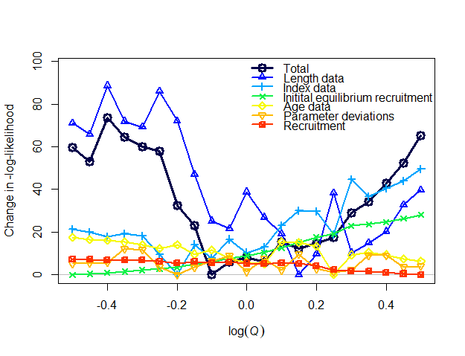

Figure Likelihood profile for Model 22.2 updated with bootstrap input sample sizes showing irregular surface for the profile and illustrating the poor model convergence.

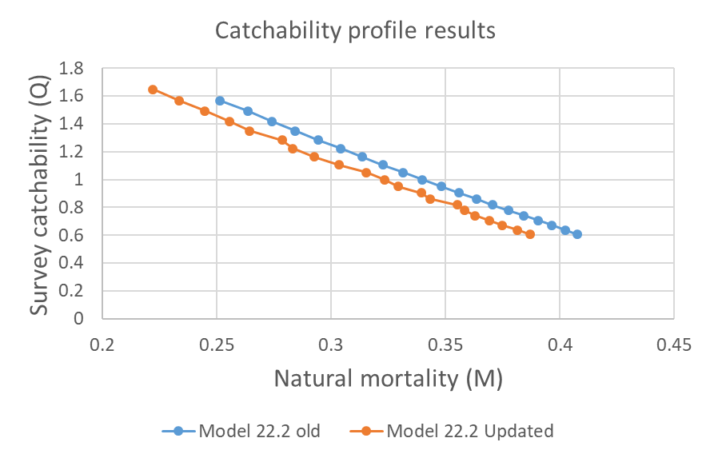

Figure Natural mortality (M) and bottom trawl survey catchability results from the profile over catchability for Model 22.2 with old and updated input composition sample sizes.

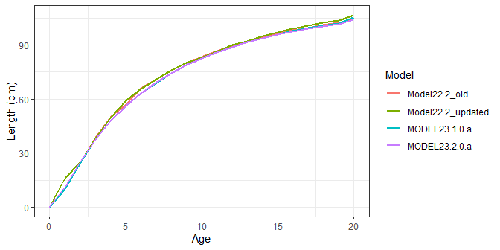

Figure Length (cm) at age for Model 22.2 old and with updated input sample sizes and for the simplified models 23.1.0.a and 23.1.0.b.

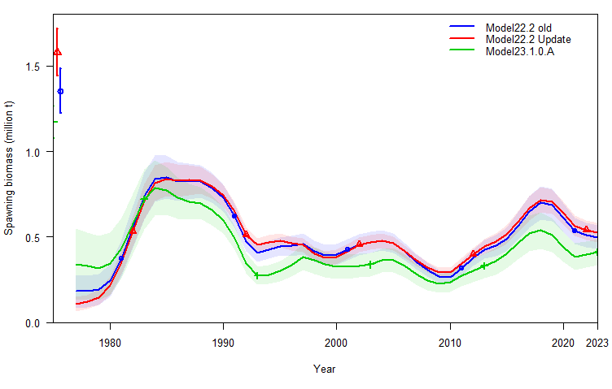 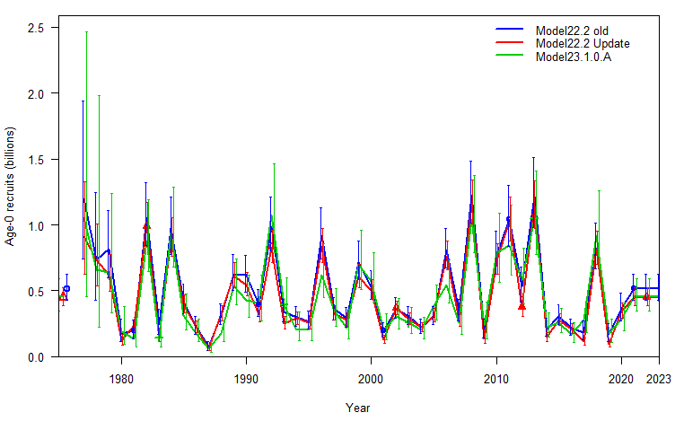

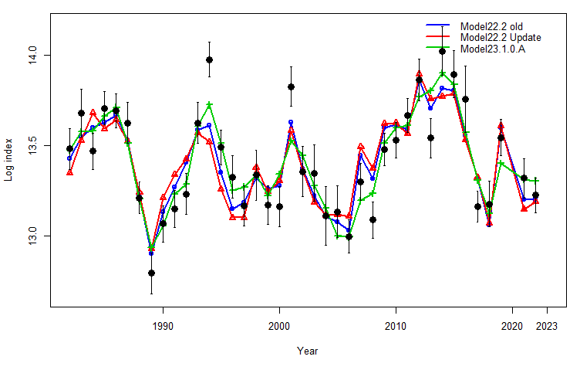 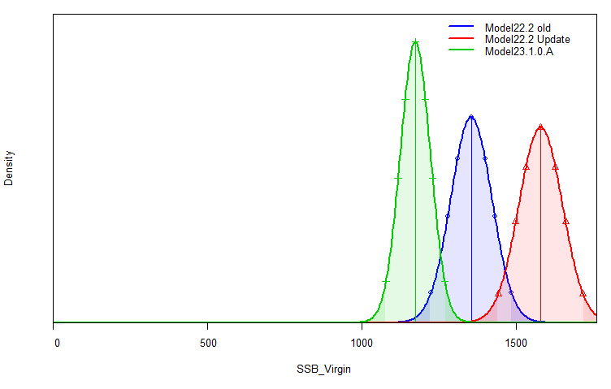

Figure Results from model fits for Model 22.2 from the 2022 ensemble models (Model 22.2 old), Model 22.2 with bootstrapped input sample sizes (Model 22.2 updated), and Model 23.1.0.A for (top left) spawning stock biomass, (top right) age-0 recruits, (bottom left) fit to the Bering Sea shelf bottom trawl survey index, and (bottom right) virgin biomass in thousands of tons.

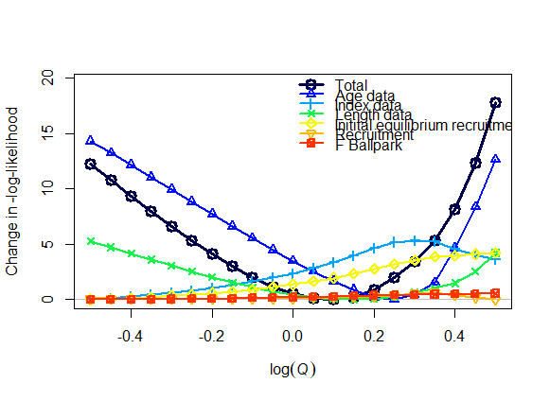

Figure Likelihood profile for Model 23.1.0.a over the log survey catchability from -0.5 to 0.5 for the main model components and in total.

b,d,g,h

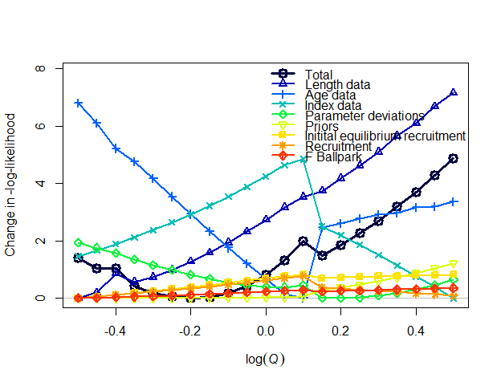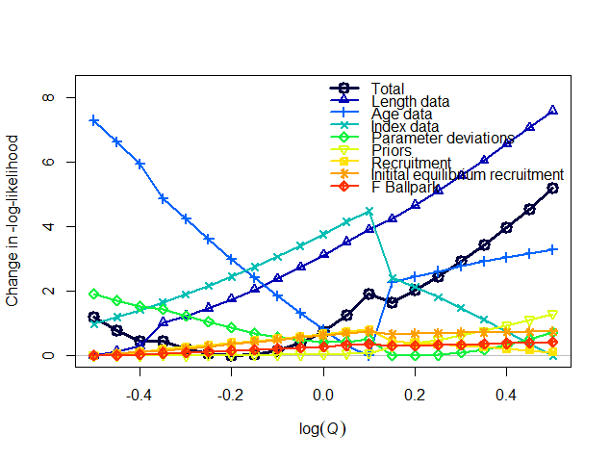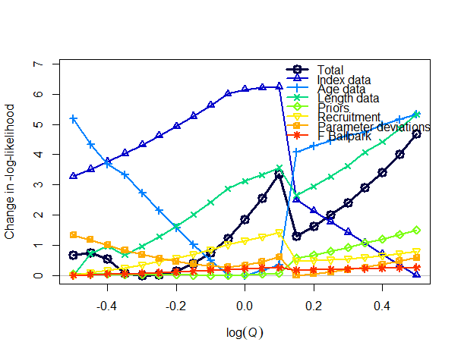

23.1.0.h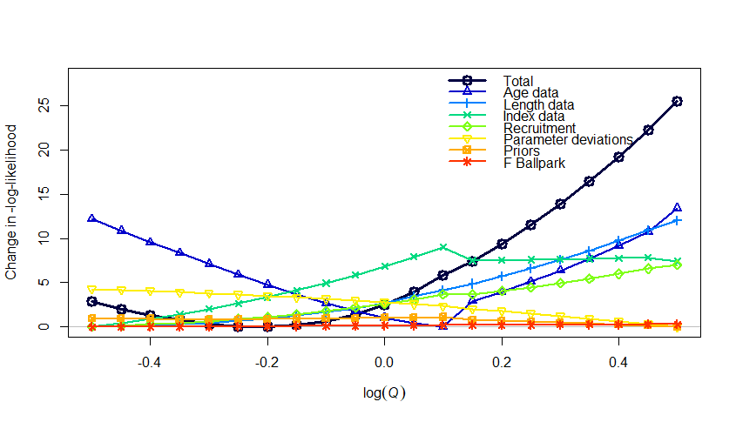

23.1.1.c

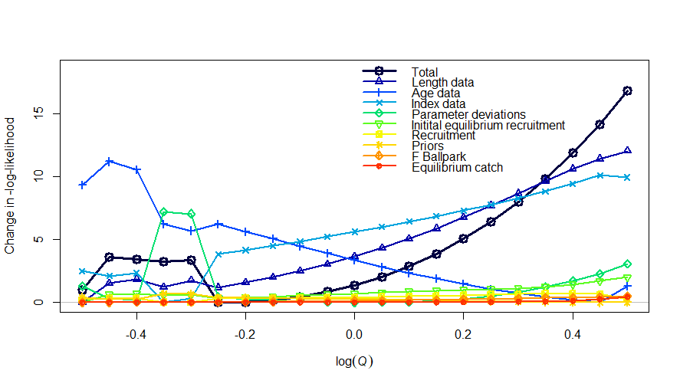

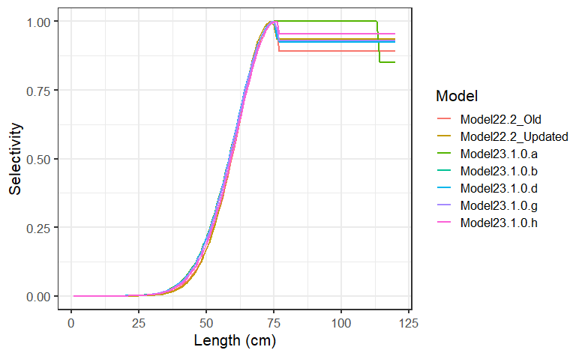 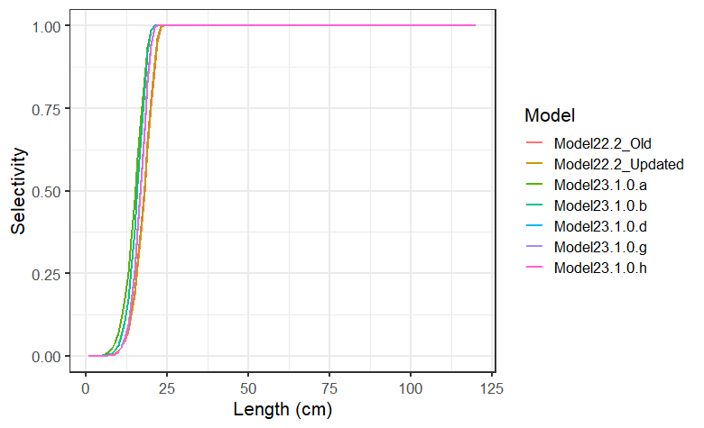

Figure Fishery selectivity in 2022 (top) and survey selectivity in 2022(bottom).

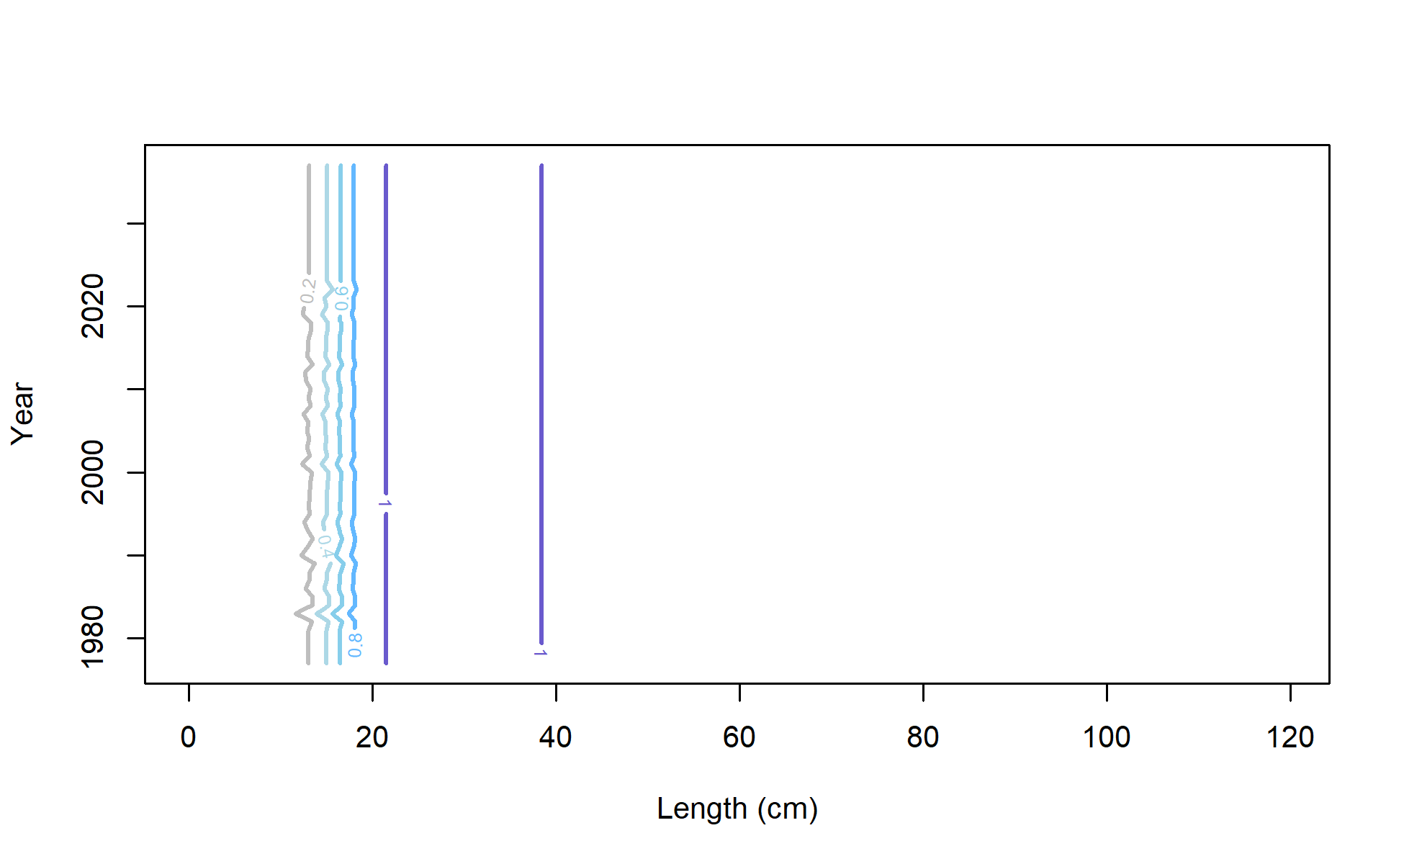

Figure Model 23.1.0.d annually varying survey selectivity.